Check the version of the POS and server systems:
Scenario: We want to check what version of Aloha NCR the FC is using.

- - Access your NCR account and click on the account icon with your name.
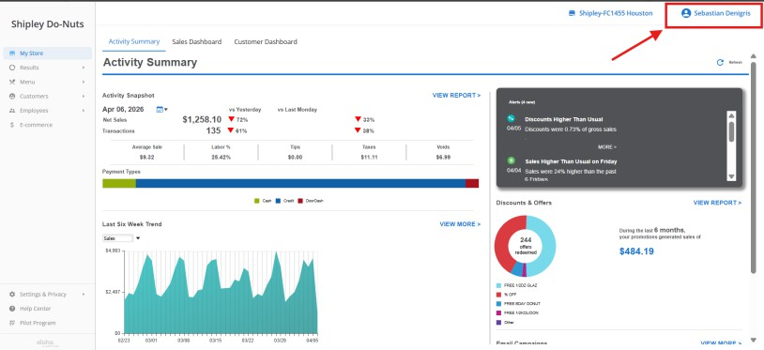

- – Click on MY ACCOUNT.

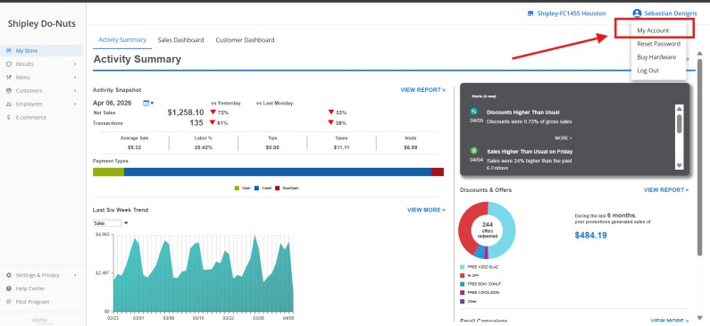

- – Click on MY DEVICES. You will then be able to check the OS version of the device on the "App version" row.
